Lab 10 :

**Download NLTK**

Pip install nltk

**Download all these libraries in PYTHON IDLE SHELL**

Execute each line separately

import nltk

nltk.download('punkt')

nltk.download('stopwords')

nltk.download('averaged_perceptron_tagger')

nltk.download('maxent_ne_chunker')

nltk.download('words')

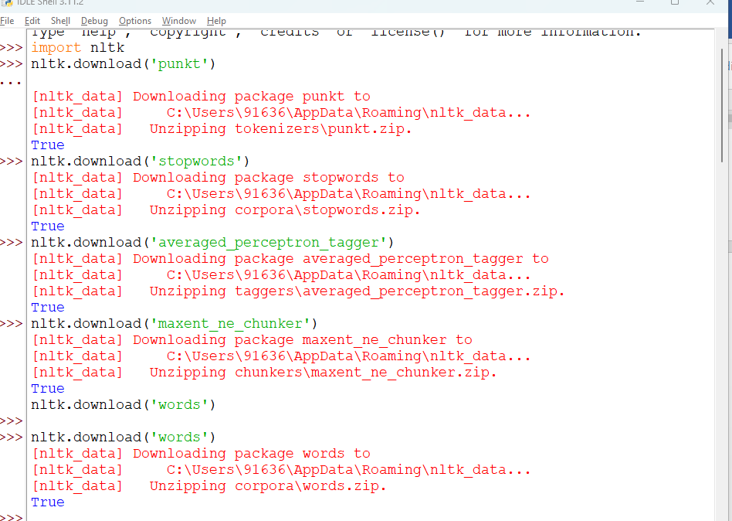

program:

import nltk

from nltk.tokenize import word_tokenize

from nltk.corpus import stopwords

from nltk.stem import PorterStemmer

from nltk import pos_tag, RegexpParser, ne_chunk

# Sample Text

text = "change is a contant thing "

# Tokenizing

tokens = word_tokenize(text)

# Filtering Stop Words

stop_words = set(stopwords.words('english'))

filtered_tokens = [word for word in tokens if word.lower() not in stop_words]

# Stemming

stemmer = PorterStemmer()

stemmed_tokens = [stemmer.stem(word) for word in filtered_tokens]

# Part of Speech Tagging

pos_tags = pos_tag(tokens)

# Chunking

grammar = r"""

NP: {<DT>?<JJ>*<NN>} # Chunk Noun Phrases

VP: {<VB.*><DT>?<JJ>*<NN|RB|VB.*>*<RB>?} # Chunk Verb Phrases

"""

chunk_parser = RegexpParser(grammar)

chunked = chunk_parser.parse(pos_tags)

# Named Entity Recognition (NER)

ner_tags = ne_chunk(pos_tags)

# Displaying Results

print("Original Text:", text)

print("\nTokenization:")

print(tokens)

print("\nFiltered Stop Words:")

print(filtered_tokens)

print("\nStemmed Tokens:")

print(stemmed_tokens)

print("\nPart of Speech Tagging:")

print(pos_tags)

print("\nChunking:")

print(chunked)

print("\nNamed Entity Recognition:")

print(ner_tags)

**output:-**

